Terraform is an infrastructure as code (IaC) tool that allows you to build, change, and version infrastructure safely and efficiently.

**STEPS For Installation-**

Google Search – Terraform DOWNLOAD

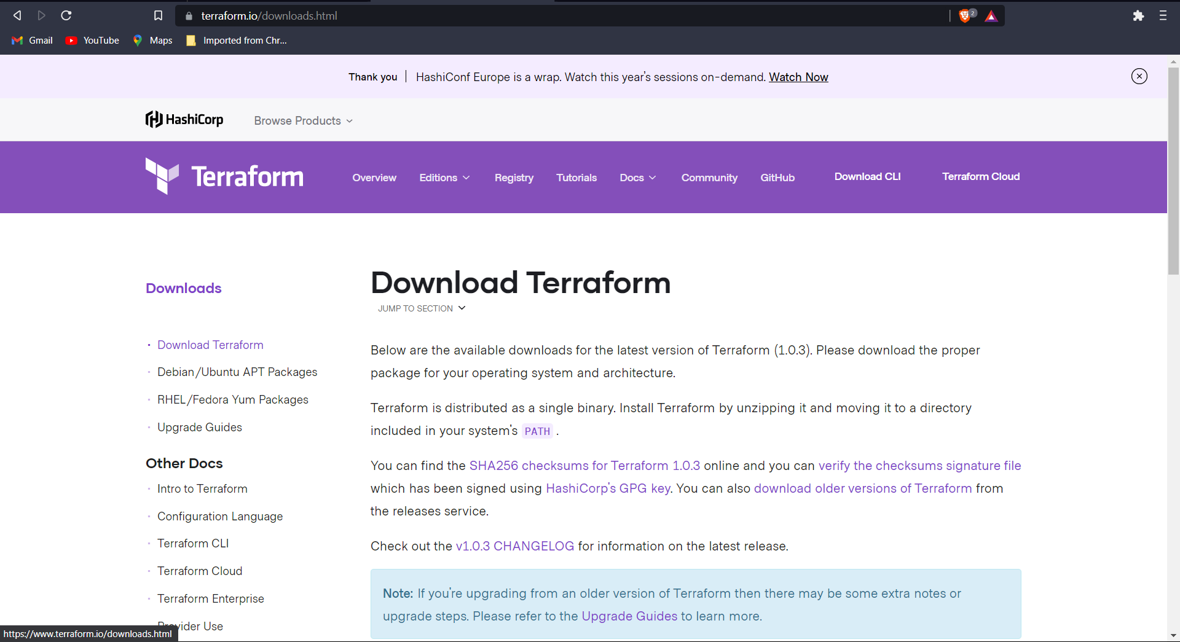

Create a Folder in Your C drive Named AdvDevops

Then Extract The downloaded file in The C drive Folder Named AdvDevops Shown Below

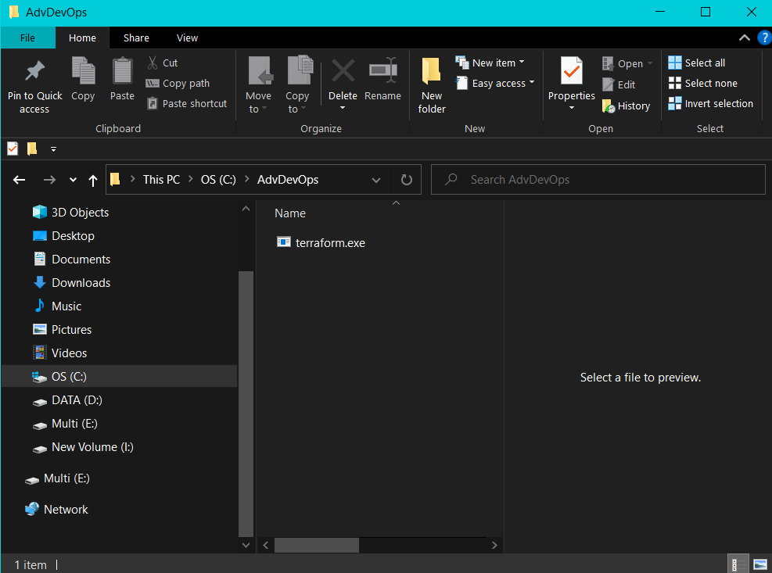

Till the time ,Open And Login to your AWS console-

And search IAM and click on it

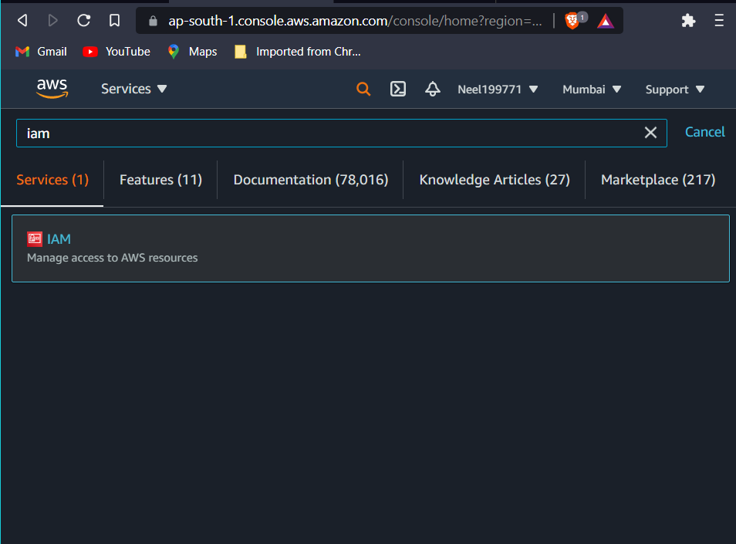

Now click on Add Users in The User Section as shown in the image

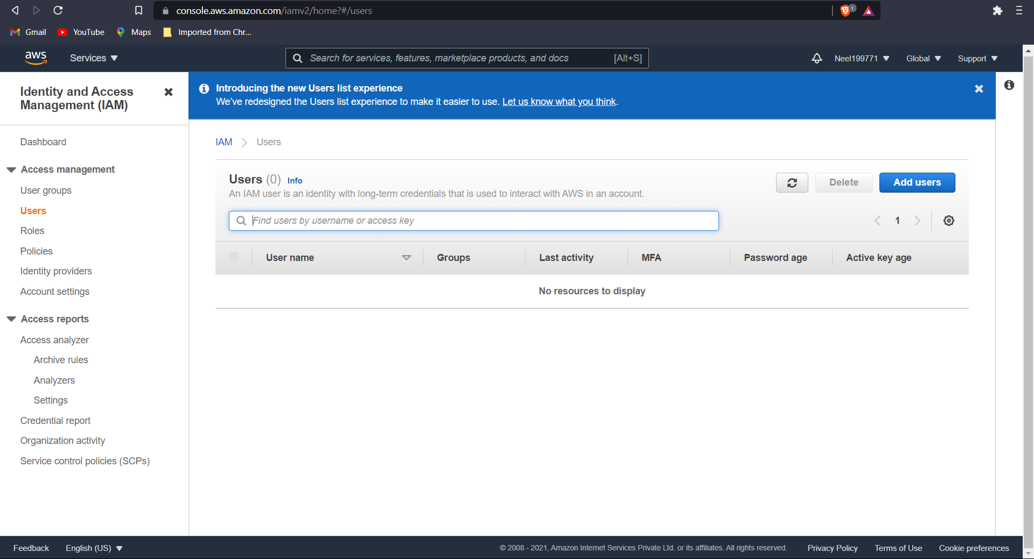

Now give any name For username And Check The Programmatic Access field shown below

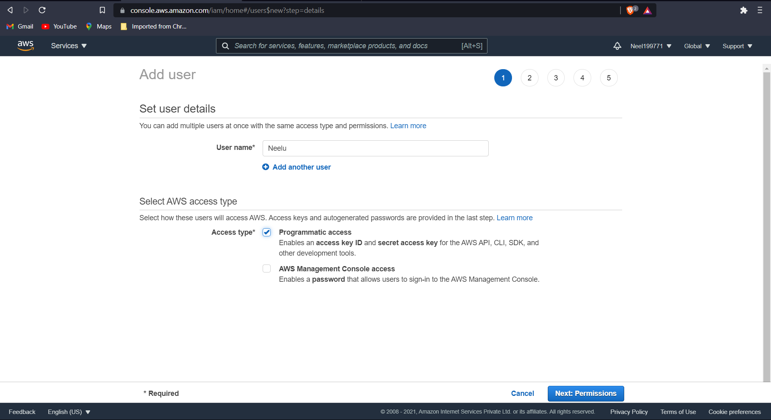

Add Group name and Check the first Policy Name

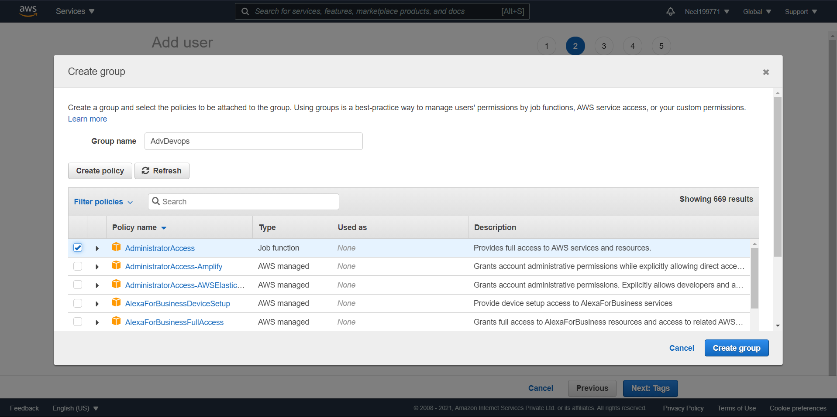

Don’t add tags

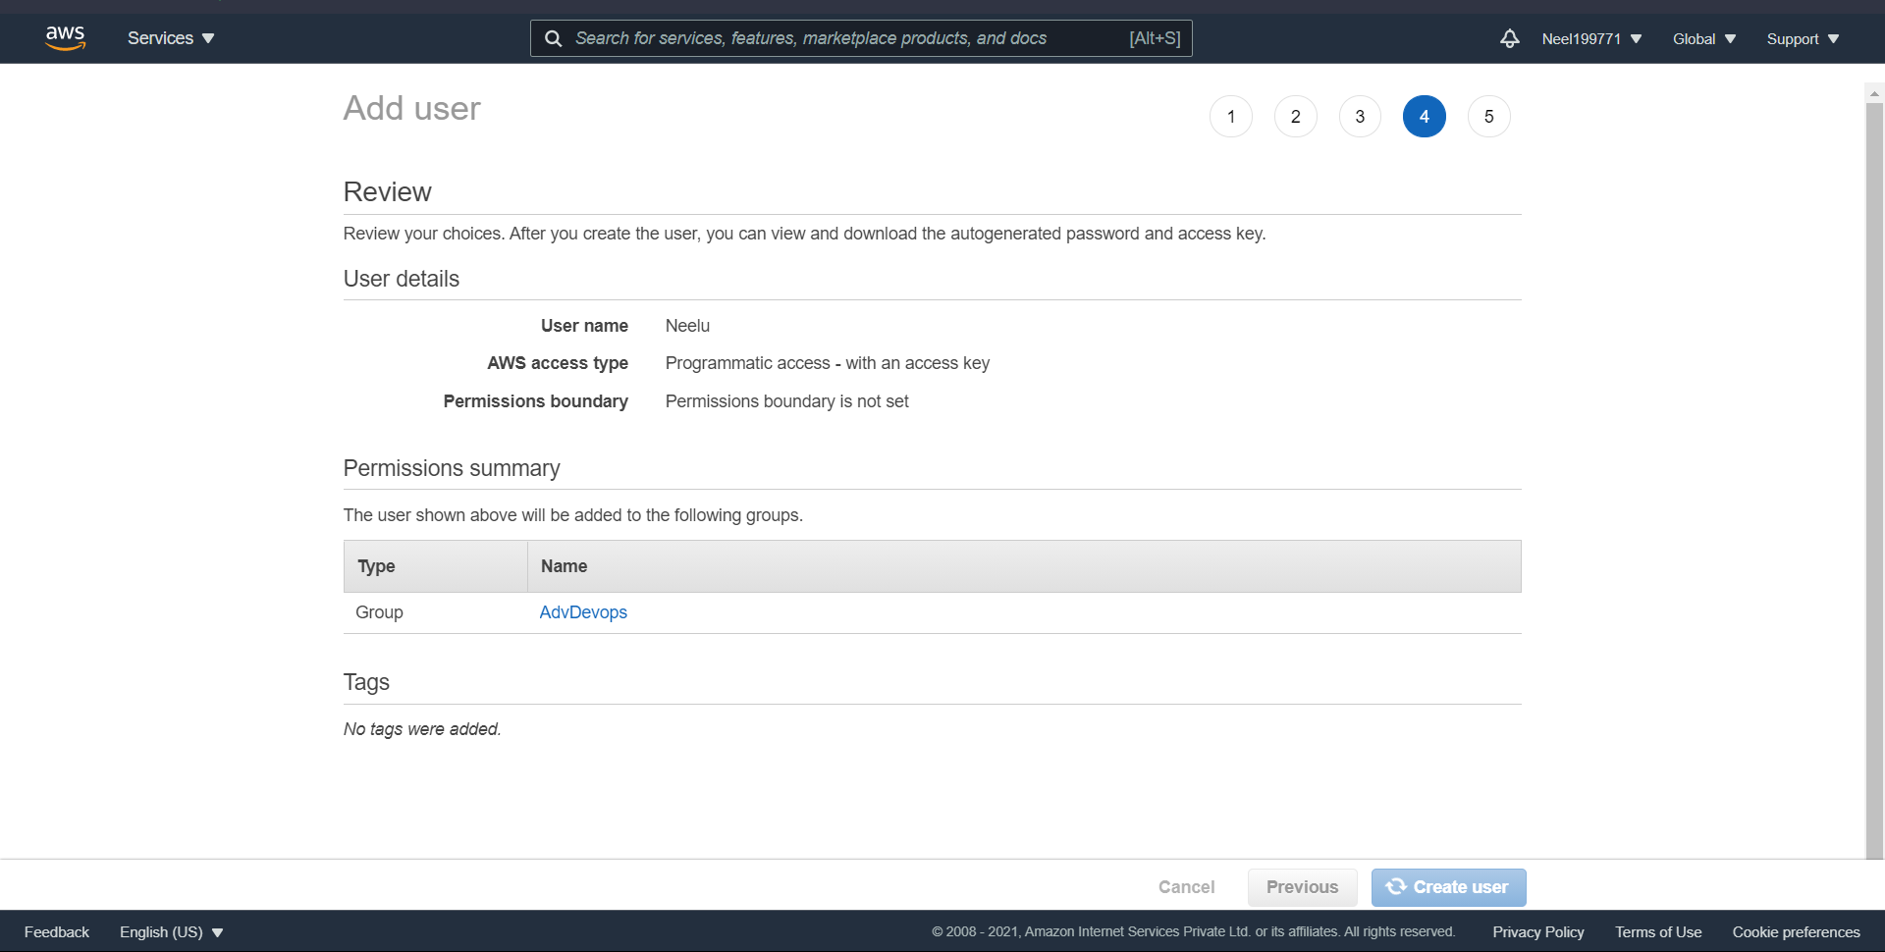

Now Download .csv file

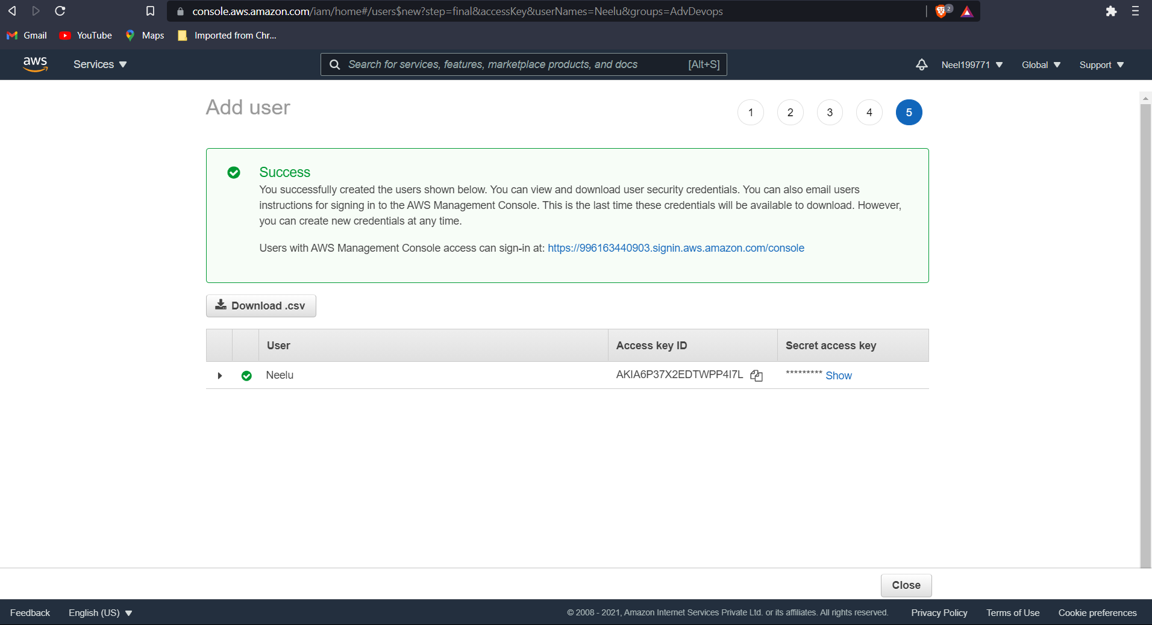

Go to services and Ec2

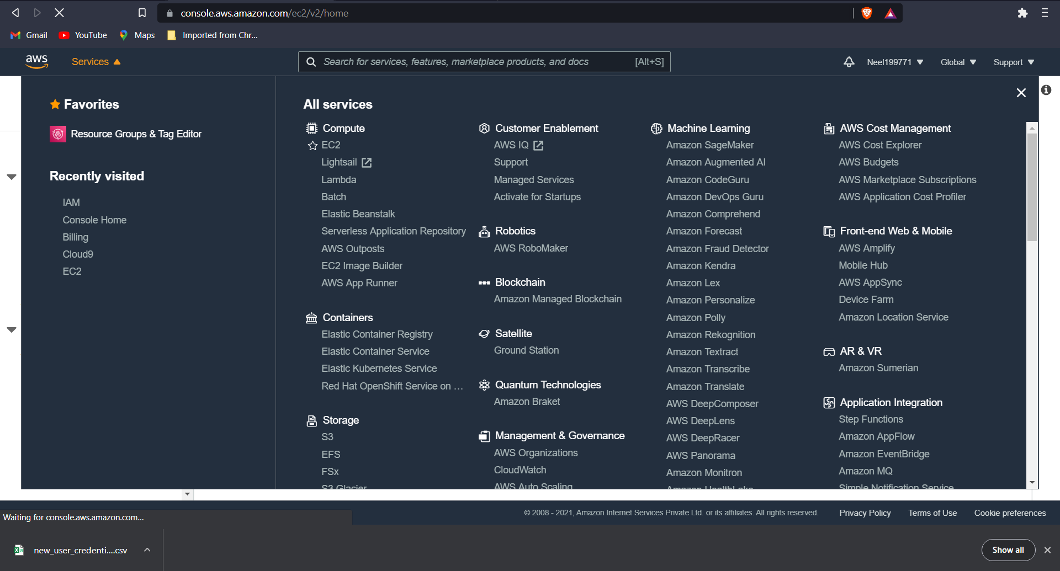

Again google search the following terms

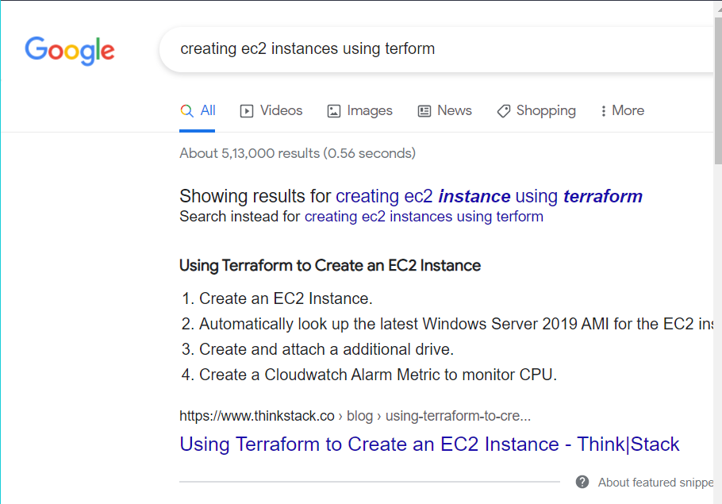

Created a folder Name Terraform Scripts in the C drive where the AdvDevops folder was created



Now Go to note pad And Type the below Details properly But before It Just Change the ACCESS KEY AND SECRECT KEY TO THE ONE IN YOUR .csv File .

Set region same as below if you want MUMBAI as your region.

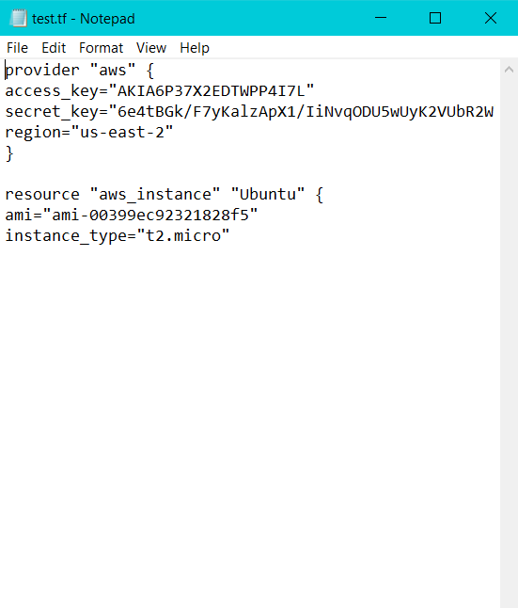

Now search EDIT THE SYSTEM ENVIRONMENT VARIABLES in your windows search.

Open it

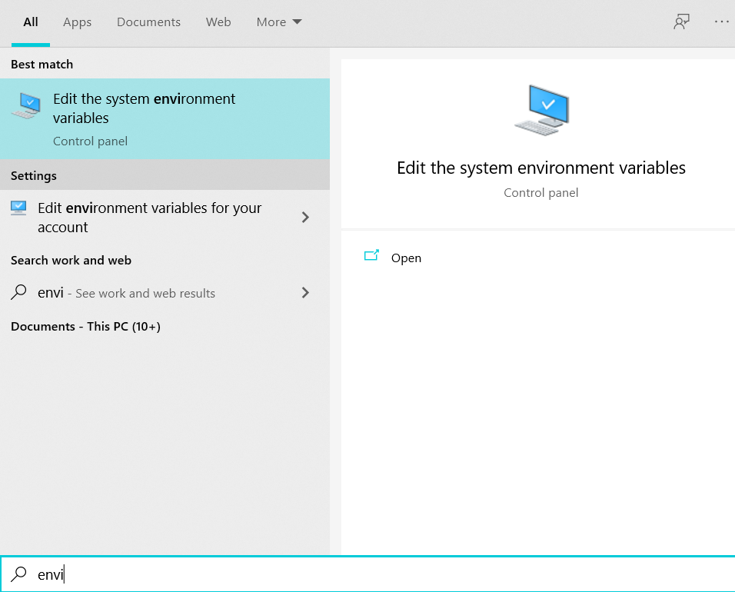

Now click on PATH OF USER VARIBLES, then click on Edit option

Now go to edit and then add new path C:\AdvDevOps

Repeat same procedure for system variables.

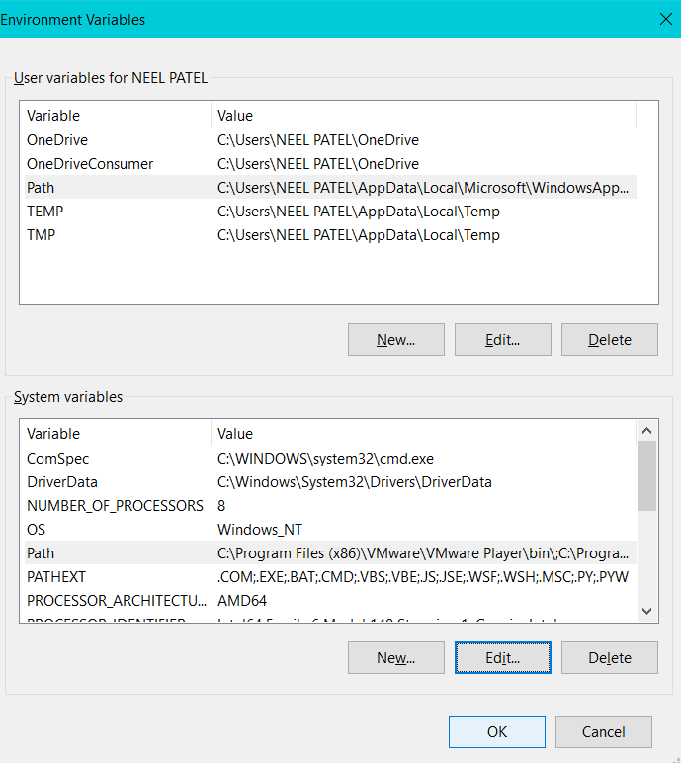

Now Open Command Prompt and then pate the path of Terraform script

Eg. CD C:\Terraform Script as shown below

Now type Terraform Init command

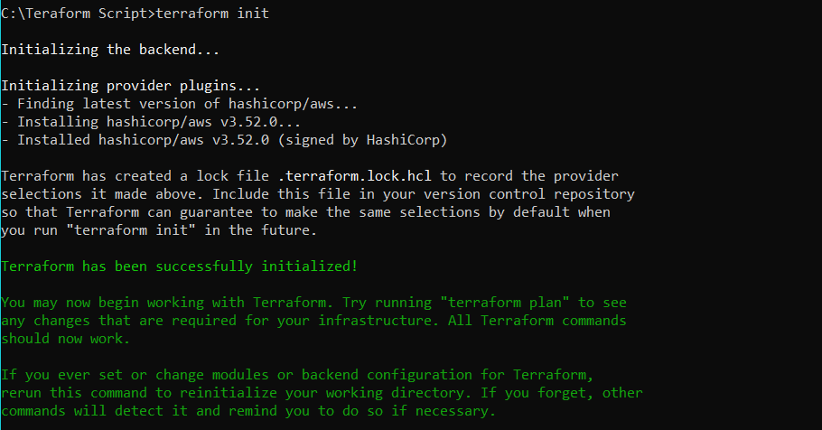

Then if there are no errors type Terraform Plan as shown below (type YES when command prompt ask)

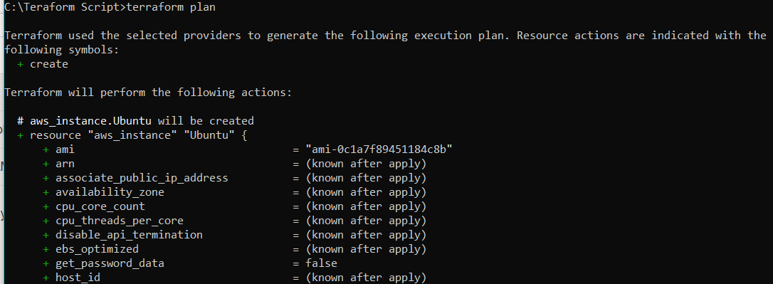

Now Finally Type Terraform Apply

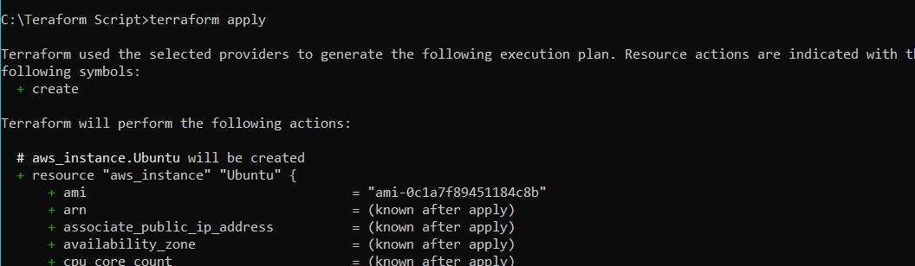

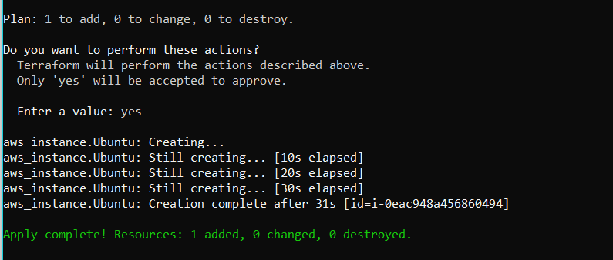

Now go to EC2 and check that is an instance created by the name of UBUNTU and is it in running status or not If it is in Running Status then Come back to Command prompt And Terminate the Instance by

Typing - Terraform destroy

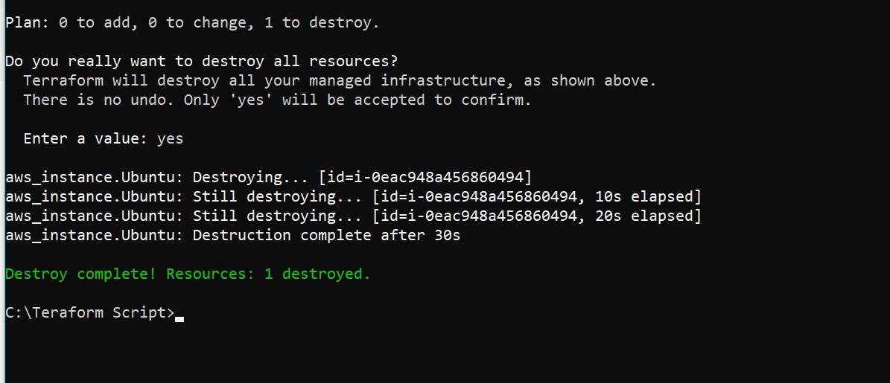

Now go back to EC2 if the instance is terminated, if yes then logout of the Aws Console.

And close the command prompt!